* Why can’t you use the P0,2/P1 ratio from Appendix B for oblique shocks?
* Go over the Prandtl Meyer derivation, especially the constant of integration thing..
* In the Handout 10 problems, and in chapters 9.7, why do you use the first turning angle for a consecutive turn?

**Note:** This book uses e to represent internal energy instead of u

**Note:** Steady flow is where the properties do not depend on time

**Fundamentals of Aerodynamics Notes**

**Chapter 1: Aerodynamics: Some Introductory Thoughts**

1.5 -

1.8 – Flow Similarity:

From our notes (ppt 7):

* Re is the ratio of inertial force to viscous force:
* Density*velocity*length/viscosity coefficient.
* Consider two different flow fields over two different bodies.
* The flows are dynamically similar if:
  1. The streamlines patterns are geometrically similar
  2. The distributions of V/V∞, P/P∞, T/T∞, etc. throughout the flow field are the same when plotted against common, nondimensional coordinates.
  3. The force coefficients are the same
* Item 3 is actually a consequence of item 2 (if P and shear stress are the same, then so is force coefficient)
* The flows are dynamically similar if:
  1. The bodies and other solid boundaries are geometrically similar for both flows.
  2. The similarity parameters are the same for both flows.
* The two main parameters are Re and M∞
  + **The flows over geometrically similar bodies at the same Mach and Reynolds numbers are dynamically similar.**
  + **So their lift, drag and moment coefficients are identical**
* This is important for model testing. Miniatures give valid values for life-size models as long as M and Re are the same.
  + (There are a few other parameters that “we’ll see later”)
  + Also freestream disturbances screw that up
* Skipped the first example problem

**Chapter 2: Aerodynamics: Some Fundamental Principles and Equations**

2.4 -

**Chapter 3: Fundamentals of Inviscid, Incompressible Flow**

3.2 – Bernoulli’s Equation:

* For an inviscid, incompressible flow:
* **This is called Bernoulli’s equation**
* To derive it, begin by considering the x component of the momentum equation. For an inviscid flow with no body force, it becomes:

Skipped this derivation.

* Which gives **Euler’s equation:**
* It applies for inviscid flow with no body forces.
  + It relates the changes in velocity along a streamline (dV) with the changes in pressure along that same streamline.
* But, for incompressible flow, density is constant. So we can easily integrate this equation between two points along a streamline. (To derive, just pull the –density out of the integral and solve, you get:)
* Which is Bernoulli’s equation! It relates the pressures and velocities of two points along a streamline.
* **Along a streamline:**
* These last two equations hold for both rotational and irrotational flow:
  + For rotational flow, the constant will change from one streamline to the next
  + For irrotational flow, the equations hold for ANY two points in the flow. So it doesn’t just apply “alond a streamline” but also “throughout the flow”
* So basically: **when the velocity increases, pressure decreases, and when velocity decreases, pressure increases**
* Since the equation was derived from the momentum formula, it is basically a statement of Newton’s second law for an inviscid, incompressible flow with no body forces.
* But the dimensions are also energy per unit volume (kinetic energy): so the work done on a fluid by pressure forces is equal to the change in kinetic energy of the flow.
  + You can also derive Bernoulli’s equation from the energy equation
  + You don’t need the energy equation for analysis of inviscid, incompressible flows.
* Skipped the rest, short and not directly important rn I think…

**Chapter 7: A Brief Review of Thermodynamics**

**7.2 – A Brief Review of Thermodynamics**

* Thermodynamics is super important for the analysis of compressible flow.

7.2.1 – Perfect Gas:

* A gas is a collection of particles (molecules, atoms, ions, electrons, etc.) which are more or less in random motion.
* These particles have force fields, their electronic structure make them interact with other particles.
* If the particles are far apart enough, intermolecular forces can be ignored.
  + Called a *perfect gas*
* Rs = 287 J/(kg*K) = 1716 (ft*lb)/(slug*oR) for air
* v is specific volume
* At the Ts and Ps for compressible flow, the gas particles are usually around 10 molecular diameters apart. Good enough for a perfect gas.

7.2.2 – Internal Energy and Enthalpy:

7.2.3 – First Law of Thermodynamics:

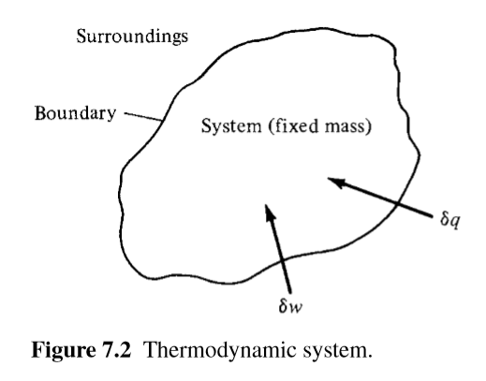

* Consider a fixed mass of gas, which we define as a *system*
  + The system is stationary
* We define the surroundings and boundary as in Figure 7.2
* δq is an incremental amount of heat added to the system across the boundary (could be radiation from surroundings or thermal conduction due to temperature gradients).
* δw is the work done on the system by the surroundings (say squeezing the volume to a smaller value)
* Since the system is stationary, the heat added and work done on the gas change its internal energy:
* This is the **first law of thermodynamics**
* **The internal energy is a state variable (like enthalpy and entropy, unlike mechanical work and heat, the two other terms in the equation)**
  + It depends only on the current equilibrium conditions, not on the path
* There are many ways heat can be added and work done on the system, we are concerned with:
  + **Adiabatic process:** No heat is added to or taken from the system.
  + **Reversible process:** No dissipative phenomena occur (viscosity, thermal conductivity and mass diffusion)
  + **Isentropic process:** both adiabatic and reversible.
* For a reversible process, δw=-pdv where dv is an incremental change in the volume due to a displacement of the boundary of the system. So this last equation becomes:

7.2.4 – Entropy and the Second Law of Thermodynamics:

* Consider a hot plate of steel in contact with a block of ice. You know that the ice will warm up and probably melt while the plate will cool.
  + But the first law allows it for the other way around as long as energy is conserved.
  + Nature imposes the *direction* that the process will take.
* Entropy is defined as follows:
* s is the entropy of the system
* is an incremental amount of head added **reversibly** to the system
* T is the system temperature
* **Entropy is a state variable**
  + But it can be used be used with both reversible and irreversible processes.
* The above equation can be better rewritten as:
* is the actual amount of heat added to the system during an IRREVERSIBLE process
* **is the amount of entropy produced** because it is irreversible. Created because of all the following within the system:
  + Viscosity
  + Thermal conductivity
  + Mass diffusion
* Because of these properties (known as *dissipative phenomena*) entropy can only ever remain constant or increase within a system:
* **If the inequality is an equal sign, then the process is reversible**
  + (no dissipative phenomena occur)
  + Reversible includes no friction
* **The equation below is the Clausius inequality:**
  + **If the process is reversible, it is an equal sign**
  + **If it is an inequality (>) then it is not reversible**
* We can combine the equations:
* And, if the process is adiabatic, then is 0:
* These last two equations are forms of the second law of thermodynamics
  + Which simply tells us in what direction a process will take place
  + *A process will always proceed in a direction that increases, or at least maintains, the overall entropy of the system and its surrounding.*
* Now remember that the first law of thermodynamics is:
* If we assume that heat is added reversibly, then you can include the equation from the second law:
* Now remember also the definition of enthalpy:
* Part of which is in the highlighted equation so:
* The two highlighted equations are basically the first law written in terms of entropy
* If you substitute the equatins for cp and cv into them you get:
* We can also use that pv = RT to get the following equation. You can then integrate to get the equation after that:
* For a calorically perfect gas, cp and R are constant:
* Similarly for the other ds equation you get:
* So s is a function of two thermodynamic properties.
  + Such as s = s(p, T) or s = s(v, T)

7.2.5 – Isentropic Relations:

* So an isentropic process is both adiabatic and reversible (ds = 0).
* So for an isentropic process, is you set s2 – s1 as 0 in both of the previous highlighted equations and solve for them , you get the following relations:

SKIPPED THE DERIVATION BUT THEY’RE NOT THAT HARD.

* You do have to know this though:
* Note: Sometime they replace the 1 subscript with infinity. I think that refers to static conditions but I’m not too sure.
* This equation is super duper important because you can assume that a lot of practical compressible flow problems are isentropic.
  + For example, on airfoils or in rocket engines, most of the non-isentropic stuff happens in the boundary layers. Everything outside of that, which is most of the flow is adiabatic and reversible.
* Note: A problem at the end showed that in an isentropic vs a non-isentropic process, if both have the same input and output pressures, temperature output will be greater for the non-isentropic.
  + This makes sense if you look at the third to last highlighted equation
* Physical mechanisms that can lead to entropy production are:
  + Viscous dissipation (friction)
  + Shockwaves
  + Heat addition from surroundings

7.5 – Definition of Total (Stagnation) Conditions:

* Static pressure: A measure of the purely random motion of the molecules in a gas.
  + The pressure when you ride along with the gas at the local flow velocity.
* Stagnation pressure: The pressure existing at a point where V = 0.
* Imagine a fluid element passing through a point in a flow where, at that point, you have a Pressure, Temperature, Mach number, etc.
  + Here P, T and density are static properties.
  + But if you grab that fluid element and **adiabatically** slow it down, p, T and density change.
* This gives the total Temperature: To with corresponding enthalpy ho
  + Ho = cpTo (for CPG)
* You don’t actually have to bring the flow to rest for those properties to exist, they are *defined quantities* that would exist *if*  you brought the flow to rest adiabatically.

SKIPPING A PRETTY LONG DERIVATION WHICH LED TO:

* I think V is velocity
* The assumptions were that the flow is steady, adiabatic and inviscid
  + **So it holds only for abiabatic flow!**
* But, if the flow is brought to rest adiabatically, then V = 0 so h = h0:
* So at any point in the flow, total enthalpy is the sum of static enthalpy and the kinetic energy (all per unit mass).

SKIPPED SOME MORE

* For a calorically perfect gas in steady, adiabatic, inviscid flow:

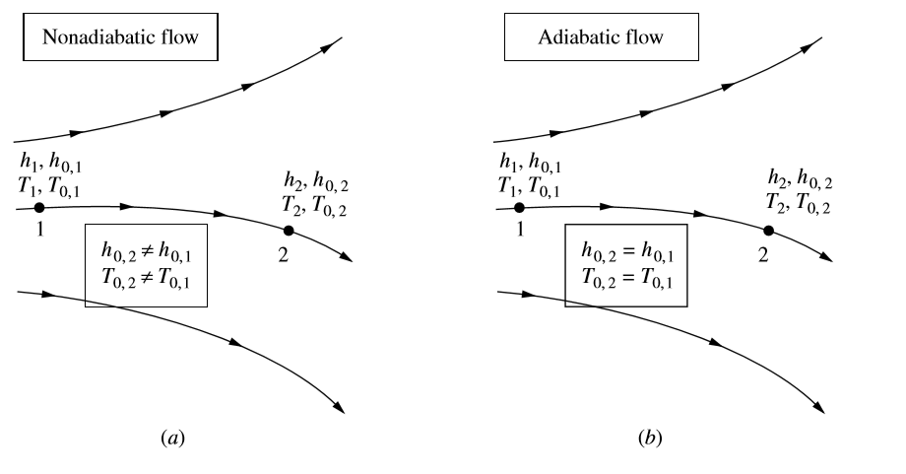

* Now, if you slow the fluid element both adiabatically and reversibly. Meaning if you slow it isentropically to 0 velocity.
  + Then you get total pressure and total density.
  + Since isentropic is also adiabatic, you get the same To as calculated before
* Remember that the isentropic assumption is only used for the definition
  + **You can use the concepts of total pressure and density to nonisentropic flow too.**

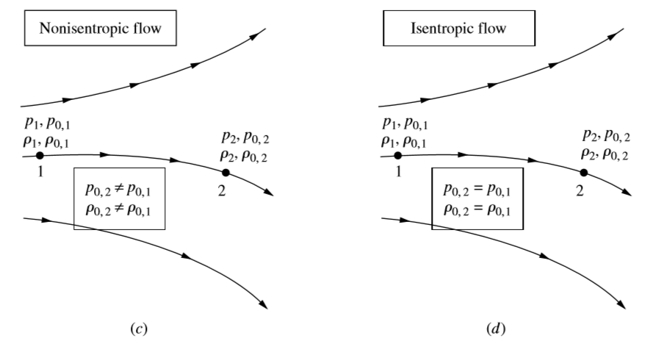

* We also define the temperature T*, which is the temperature if the flow was slowed down or accelerated to sonic speed.
  + A* = sqrt(yRT*);

7.6 – Some Aspects of Supersonic Flow:

* A subsonic compressible flow is qualitatively the same as incompressible flow (but not quantitatively)
* IN subsonic flow, you have smooth streamlines and the flow ahead of the body is forewarned about its presence. It adjusts accordingly.
* In supersonic flow, the flow does not know about the body until it hits the leading edge.
  + Flow is dominated by shockwaves
  + Any flow with a supersonic region will have shockwaves
* A shock wave is an extremely thin region, about 10-5cm large, across which flow properties change drastically.
  + It is an almost explosive compression process, the pressure increases almost discontinuously
  + Shockwaves are usually at an oblique andgle but we focus on normal shock

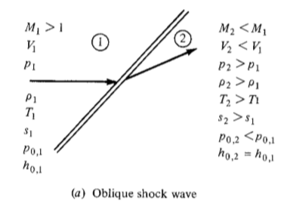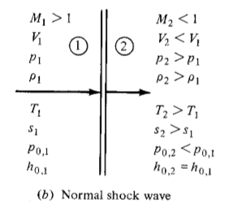

* The following increase across both shocks:
  + Pressure
  + Density
  + Temperature
  + Entropy
* The following decrease across both shocks:
  + Total Pressure
  + Mach Number
  + Velocity
* **The flow across a shock is adiabatic**
  + That’s why the total enthalpy is constant
* For both shocks, the upstream flow must be supersonic
* For normal shock, the downstream flow is always subsonic
* For oblique shock, the downstream flow is just slowed down and remains supersonic
  + There are special cases where it can decelerate it to subsonic speeds
* Interesting Note:
  + You can’t usually see shock waves with the naked eye because air is transparent.
  + But, because the density changes, light rays are refracted across the shock.
  + You can use optical systems (shadowgraphs, schlierens, interferometers) to see the shock wave.
  + Also remember that some supersonic regions on an airfoil in subsonic flow cause shockwaves. You might be able to see these.

**Chapter 8: Normal Shock Waves and Related Topics**

8.2 – The Basic Normal Shock Equations:

* Basically this subchapter tries to calculate the downstream properties given the upstream properties.

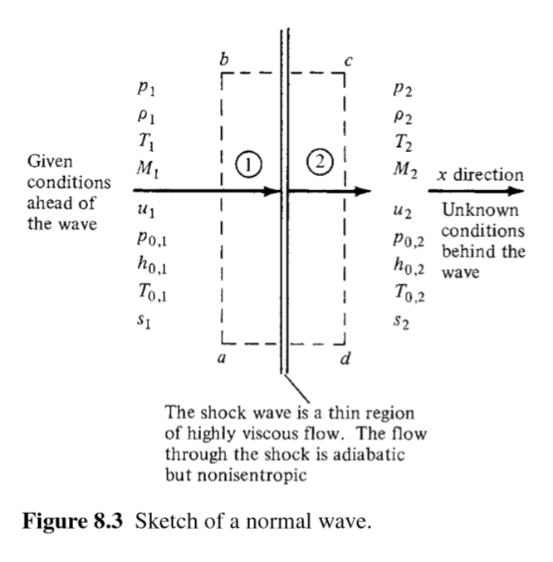

* Start by considering the rectangular CV abcd within which there is the shockwave
  + Both faces ab and cd are perpendicular to the flow and have area A
  + We apply the integral form of conservation equations to the control volume
* The following important observations are made:
  + The flow is steady
  + The flow (and thus control volume) is adiabatic
    - **The increase in temperature is because kinetic energy is converted to internal energy in the shock wave NOT because heat is added/removed**
  + There are no viscous effects on the sides of the control volume
    - The shock wave is just a thin region of high velocity and temperature gradients
  + There are no body forces: f = 0

SKIPPED A DERIVATION USING THE CONTINUITY EQUATION THAT GAVE THIS:

* Which is the continuity equation for normal shock waves.
* For the momentum equation

SKIPPED A DERIVATION USING THE MOMENTUM EQUATION THAT GAVE THIS:

* Which is the momentum equation for normal shock.

SKIPPED A DERIVATION USING THE ENERGY EQUATION THAT GAVE THIS:

* Which is the energy equation for normal shock waves
* Then we add two already known thermodynamic relations. The five equations are summarized on the next page.
* Note that the first three are not limited to normal shock waves
  + They work for any inviscid, steady, adiabatic flow **where only one direction (x) is involved.**
  + 1 Dimensional flow

8.3 – Speed of Sound

* Sound is propagated by the vibration of air molecules.
  + A detonating cracker transfers chemical energy and starts these vibrations.
* The regions of energized molecules experience slight variations in local Temperature, pressure and density.
  + You hear this difference in pressure
* According to kinetic theory, molecules in a gas move at an average velocity of:
  + We expect the velocity of propagation of sound to be the average molecular velocity
  + The speed of sound is about three quarters the average molecular velocity
* Speed of sound depends only on temperature (based on above equation)
* Okay now consider a sound wave propagating through a stagnant gas with velocity a.
  + The properties change a little bit behind the wave.

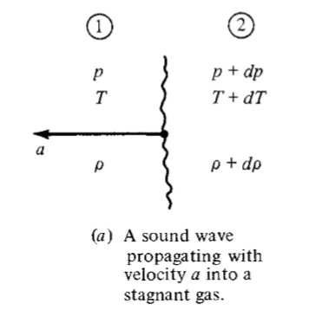

* Now, instead, imagine that you are moving with the wave
  + When you look upstream into region 1, the gas is moving towards you at velocity a
  + When you look downstream into region 2, the gas is moving away from you at velocity a + da

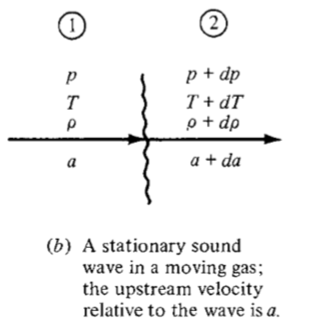

* Note that this sound wave is really just an infinitely weak normal shock wave.
* If the oncoming flow was suddenly shut off, then the shockwave would propagate left with velocity u1.
* The flow is one dimensional and adiabatic
  + In fact, it is isentropic

The rest of this chapter is mostly a derivation that I don’t fully understand and that just leads to:

Skipped the rest

8.4 – Special Forms of the Energy Equation

* So in section 7.5 we obtained that for steady, adiabatic, inviscid flow:
* All subsequent calculations work for a streamline, not just 1D flow
* Also remember that u is the flow velocity, a is the speed of sound.
* So then you can substitute that h = CpT (gives you an important equation)
* Then you substitute that h = yR/y-1
* Then you substitute that a = sqrt(yRT)
* If you do all that correctly, you get:
* But look, at a stagnation point (like a point on the streamline where u becomes 0):
* The stagnation speed of sound is associated with the specific point where a and u are measured.
  + Notice that along a streamline, the right side of the equation is equal to a constant, so you can combine the two highlighted equations for points along a streamline.
* But if you look back at the first highlighted equation and remember that we defined a property with a * as the property at sonic speed then
  + At a sonic point
* Again this a* value is associated with a single point
* Also, the right side is again constant along a streamline
* If the streamlines originate from the same uniform free stream conditions, then ao and a* are constants throughout the entire field
* Also the right side of the last two highlighted equations are equal.
* Remember that:
* Remember that T0 is constant for an adiabatic flow, which means that the right side is constant along all points in a streamline
* **The stuff below is for CPG for some reason…**
* If you solve the above equation for T0/T (the ration of total to static temperature), you get:
  + Note that you have to make two substitutions, one for Cp and one for M
* From somewhere else, we have that:
* This is super duper useful because you can use it in the isentropic relationships from section 7.5 I think:

ALSO FROM HANDWRITTEN NOTES FROM ???:

* Again these are important because they dictate that for isentropic, steady, inviscid flow, the ratio of stagnation properties to static properties is only a function of Mach number and gamma.
* Values from these equations are tabulated for various Mach numbers at y=1.4
  + That’s how important these equations are fool.
* Now if you consider points in the general flow where the velocity is sonic, you get these:
* For y = 1.4 (which is air) you get the following values for the three equations
  + 0.833
  + 0.528
  + 0.634
* So then they define this: M*=u/a*
  + Technically, a* isn’t the same speed of sound, it’s slightly different
  + Think of it like a0
* If you use the equation that I highlighted in blue instead of yellow and solve using the definitions of Mach number, you get this:
* And
* Basically:

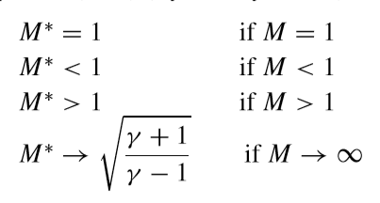

8.6 – Calculation of Normal Shock wave Properties:

* We start by going back to the 5 key equations from section 8.2
* They start this derivation by dividing the momentum equation with the continuity equation.
  + They solve for it a bit and then substitute the definition of a = sqrt(yp/row);
  + Then they use the blue equation to substitute a1^2 and a2^2
  + They solve for it and, in the end, you get:
* This is called the Prandtl relation, it can also give you things like this:
* Then, if you solve for this by substituting the last highlighted equation in the last section, you get:
* **So the Mach number behind the wave is a function only of the Mach number in front of the wave.**
* You can see a few very important things from this:
  + If M1 is supersonic, then M2 is subsonic
    - In fact, as M1 increases above 1, M2 becomes smaller and smaller because the shockwave gets stronger
    - But M2 approaches a finite value as m1 approaches infinity: sqrt((y-2)/2y)
    - Which is 0.378 for air
  + If M1 = 1, then M2 = 1 (this is an infinitely weak normal shock wave called *Mach* wave)
  + Note that there is no third case where M1<1 because then there wouldn’t be a shockwave you idiot

I decided to skip the derivations, which usually involve playing around with those last few formulas, but they give you these ratios:

GO BACK AND REVIEW THESE IF TIME

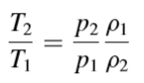

ADDITIONAL HANDWRITTEN NOTES FROM ???:

* **Observe that the difference between these and the original isentropic relations is that the original ones compared the stagnation properties with the static properties. These compare the properties ACROSS A SHOCK WAVE.**
* All those are functions of the upstream mach number only
  + All of them are equal to 1 if ach number is 1 (a Mach wave)
* **This is all for a CPG**
* 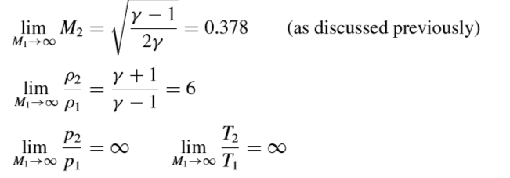The limits are:
* So then they take one of the equations for the second law and substitute the equations we have here for ratios, they simBGplify it and conclude that
  + If M = 1, there is no entrpy change across the wave
  + If M > 1, there is an increase in entropy across the shock wave
  + If M < 1, there is an entropy decrease, which is impossible, so the equtions don’t apply for subsonic speeds

Skipped A LOT of stuff here but those seem to be the useful equations:

* **Stagnation temperature is constant across a normal shock!**

**Chapter 9: Oblique Shock and Expansion Waves**

9.2 – Oblique Shock Relationships:

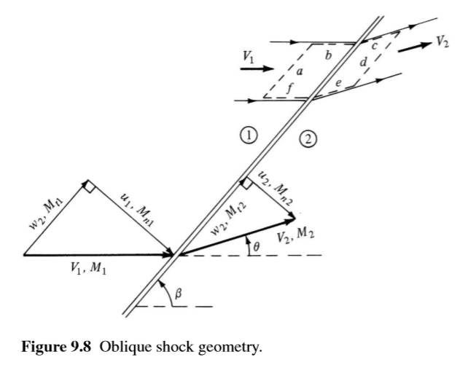

* Consider the following oblique shock.
* β is the angle between the oncoming flow and the shockwave.
* The downstream flow is deflected by angle θ
* We split M1 and M2 into their normal and tangential components
* Then, they do the same thing they always do (and which I skipped) which is apply the continuity equations to the control volume defined by the dashed lines
* Continuity equation for oblique shock:
* The tangential component in the momentum equation for oblique shock becomes:
  + Which is important because it states that the tangential component of the flow velocity is constant across an oblique shock
* The normal component in the momentum equation for oblique shock becomes:
  + Remember that *the velocities in this equation are the normal components of the velocities*
* The energy equation for oblique shocks become:
  + Total enthalpy is constant across the shockwave
  + **For a CPG, total temperature is constant across a shock**
* Basically the tangential components to the shock don’t do shit
* You can use all the equations from chapter 8.6 but remember to use the normal mach component:
* **Note: These are the notes from our powerpoint (we use different notation):**

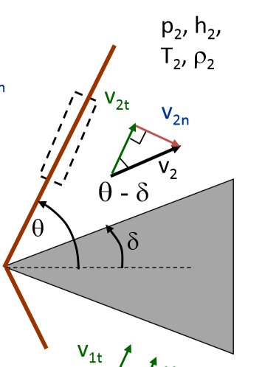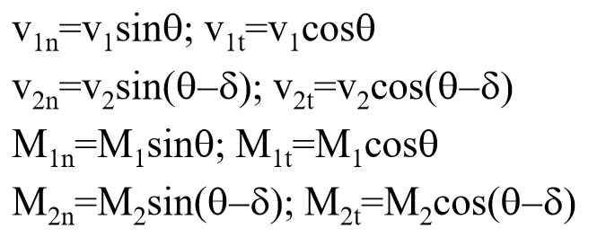

* So basically changes in ratios across an oblique shock depend on the normal component of the incoming mach number which itself is dependent on the incoming mach number and the oblique shock wave angle.
* Then they do that tan(beta) = tan(u1/w1) and tan(beta-theta)=u2/w2
  + They divide those two and use the continuity equation for oblique shock
  + Then they substitute the isentropic relations (using M1 not M) for densities
  + They do complex trig trics and get:
* 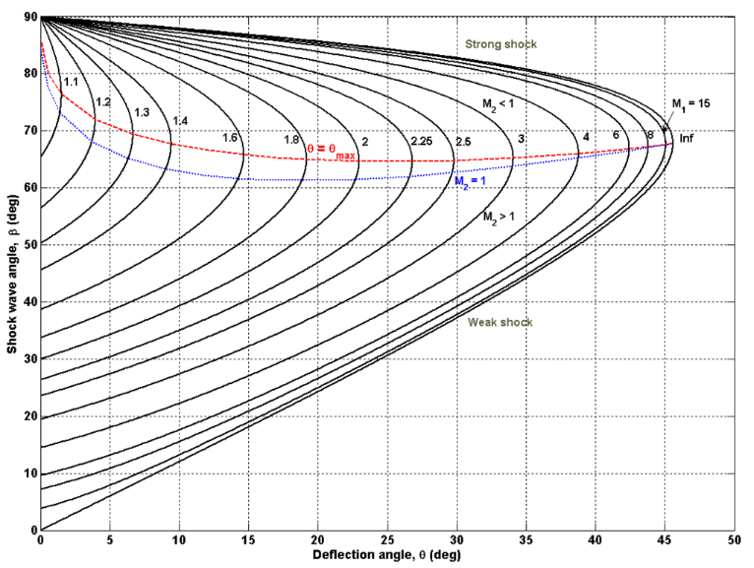REMEMBER THAT THETA HERE IS DELTA IN OUR NOTATION AND BETA IS THETA IN OUR NOTATION
* This equation is called the θ-β-M relation
* They take this equation and plot it for a number of different Mach numbers, it looks like this:

They list the following properties for oblique shocks:

1. If the deflection angle is less than the max, you get a straight, attached oblique shock. If you increase it beyond that, you get a detached, bow shock.
   1. As you increase Mach number, this max angle increases too but up to a limit. As M1 approaches infinity, θmax approaches 45.5o for y = 1.4
2. Remember that if θis below θmax then you get a strong and a weak shock solution. One is strong because more normal component so greater p2/p1 ratio.
   1. Above the top line, which connects all the θmax, the strong shock prevails. Below it, weak shock
   2. In reality, you usually get the weak shock
   3. **The bottom of the two horizontal lines describes the Mach number after the wave (above it M2 < 1, below it M2 > 1)**
   4. So it is usually supersonic after shock because most of the time you get weak shock
3. If the deflection angle is 0, then the shock is at 90 degrees, which is a normal shock
4. If you maintain the same deflection angle but increase the Mach number, you will get a smaller oblique shock angle right? Yet that shock is stronger!
5. If, in comparison, we keep M constant and increase the deflection angle, then the shock will become more normal and stronger.

* **For Oblique shocks, you can’t use the P0,2/P1 ratio because it is really just valid for normal shock. Instead, you can just use isentropic relations to find P0,1/P1 and stuff and then use ratios!**
  + **Basically, you can’t do the Mn,1 substitution for M1 in equation 8.80**

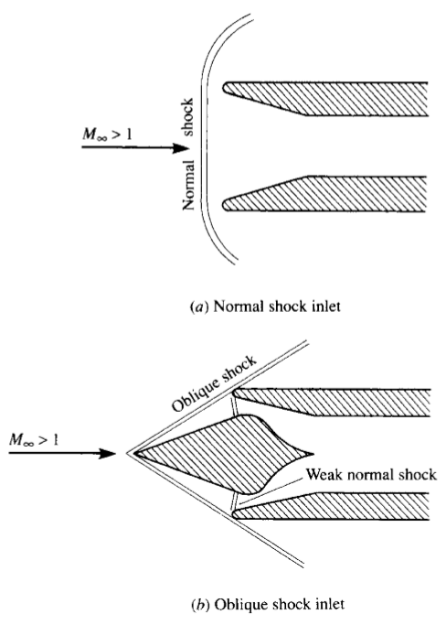

You only need to define two properties of an oblique shock to describe it fully. With M and β for example, or M and θ.

* + When we just looked at normal shock, we only needed M to fully define it. But that’s because the β was assumed to be 90o!
* The total pressure is a measure of how much useful work can be done by the gas (everything else being equal). So processes with a lower total pressure decrease are more efficient.
  + We usually try to reduce the speed of a flow using an oblique shock before putting it through a normal shock.

9.3 – Supersonic Flow Over Wedges and Cones:

* So for wedges, what we just studied is an *exact* example, there were no simplifying assumptions.
* A wedge flow is two dimensional because the picture below just stretches infinitely far perpendicular to the page.
* But for a cone, the only similarity is that there is an oblique shock that stems from the nose.
* Because the flow over the cone is 3D, it can more easily adjust to the presence of the conical body.

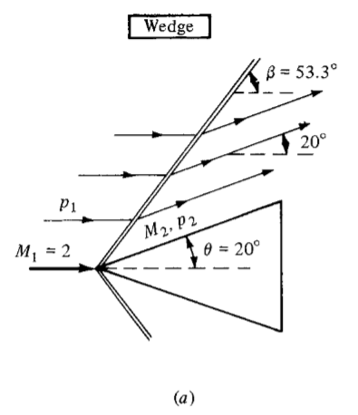

* As a consequence, the shockwave on the cone is weaker than the one on the wedge for the same deflection angle and M1.
  + It has a smaller wave angle
* In the wedge, the flow after the shock is completely parallel to the wedge everywhere.
  + In the cone, the flow after the shock directly next to it is also parallel (20o) but for the rest, because of the weaker shock, it is deflected a lot less.
  + So the streamlines must curve upward as they get closer to the cone.
* **Also the static pressure on the cone is less than the one on the wedge and the Mach number is greater. Why? Shouldn’t it be**
* Supersonic flow over a cone is only looked at in chapter 13. Basically the differences are:
  + Weaker shock
  + Lower pressure after
  + Curved streamlines
* **SKIPPED THE REST, COVERS SUPERSONIC LIFT AND DRAG COEFFICIENTS**

9.4 – Shock Interactions and Reflections

* So, the oblique shock wave that you create at the wedge does not extend to infinity. It will eventually hit a solid or other waves.

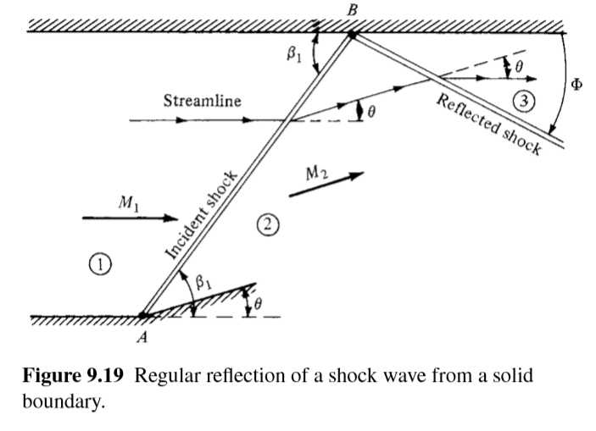

* Consider the shock generated at point A in figure 9.19. The upper wall is straight and horizontal.
* The shock wave then hits the wall at point B.
* We know that the flow behind the incident shock must be at an angle θ. But we also know that the flow must be tangent everywhere along the wall!
* So the flow in region 2 must be bent back through an angle of θ.
* This happens through a second shockwave (a *reflected shock wave*) that originates at point B.
* The reflected shock is weaker than the incident shock because M2 < M1 but the deflection angle is the same. (If the deflection angle is the same but M is lower, the shock is weaker)
  + So the angle that the reflected shock makes with the wall is different from β1
* Reflected shock is only dependent on M2 and θ. M2 is uniquely defined my M1 and θ so, to find stuff about the reflected shock

1. Calculate properties in region 2 using given M1 and theta.
2. Calculate properties in region 3 unsing calculated M2 and theta.
   1. **You use the exact same theta as your deflected angle – find the shockwave angle using the diagram with all these curves. This is the angle between the reflected shock and the oncoming flow.**
   2. **To calculate the angle between the reflected wave and the wall:**

Mach Reflection:

* There’s an interesting case: if the incoming Mach number is just above what is needed to maintain a straight oblique shock (as opposed to a bow shock) then it may slow down enough so that it’s not fast enough to maintain a straight oblique shock after the wave.

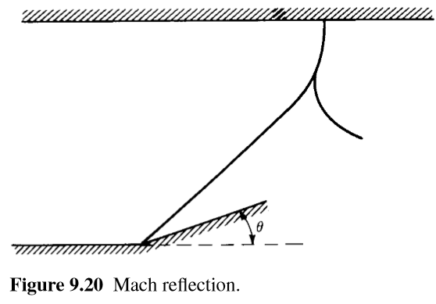

* So the incident shock will curve as it nears the wall and form a normal shock wave at the upper wall.
* A curved rreflected shock also branches off from the normal shock.
* This overall pattern is called a Mach reflection.

Other type of Reflection:

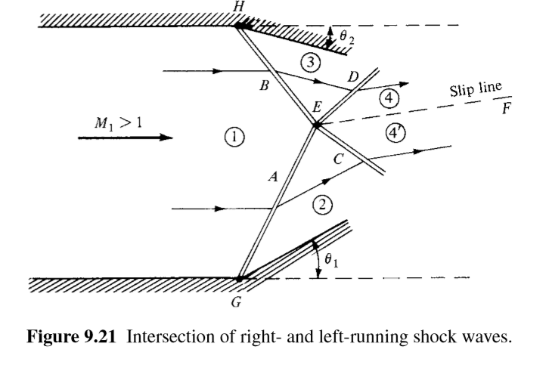

* Shockwave A is created at corner point G. It is a *left-running wave* because, if you stood on it and looked downstream, the flow would seem to be flowing forward and left.
* Shockwave B is created at corner point H. It is a *right-running wave*.
* They intersect at point E. Wave A is refracted and continues as wave D. Wave B is refracted into wave C.
* The two regions of flow that follow these waves – 4 and 4’ – are divided by a slip line EF. Their pressures and direction of velocity are the same.
  + However, their magnitude of velocity can be different.
  + **All other properties are also different.**

Interaction of Two left-running Waves:

* Two left-running waves generated at corners A and B.

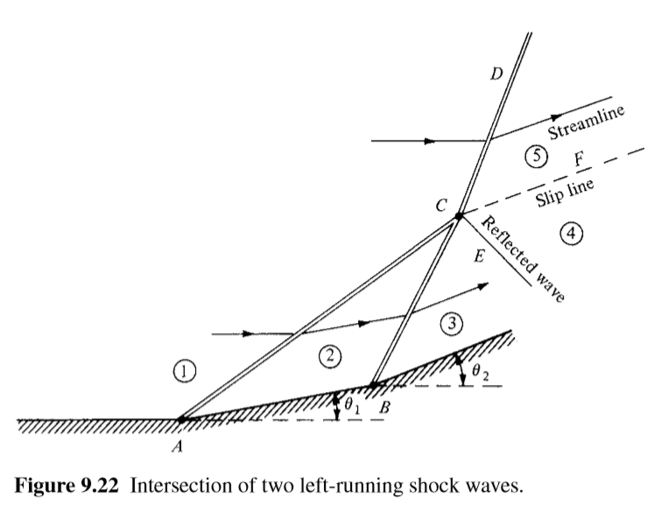

* They merge at C and continue as the strong shock CD.
* Usually accompanied by a weak reflected wave CE.
  + The weak shock is necessary to adjust the flow so that velocities in regions 4 and 5 are in the same direction.
* There are more possible wave interactions but those are the most common.

9.6 – Prandtl-Meyer Expansion Waves:

* Basically, if a supersonic flow is turned away from itself as opposed to into itself, you get an expansion wave.

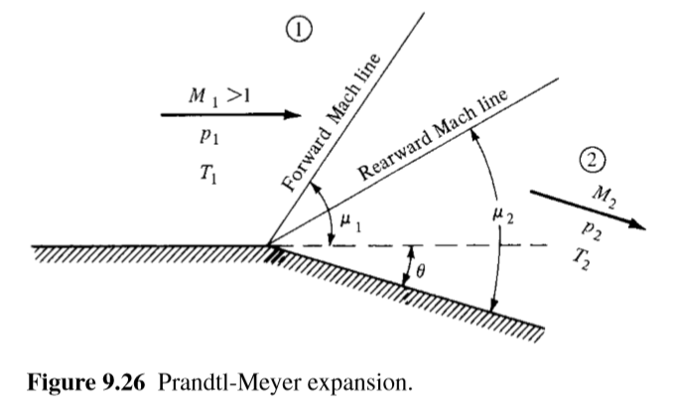

* + This section develops a theory to calculate changes in flow properties across expansion waves.
* The expansion fan in Figure 9.2b is a continuous expansion region, it is an infinite number of Mach waves.
* The fan is bounded upstream by a Mach wave which makes the angle with respect to the upstream flow.
* It is bounded downstream by a Mach wave that makes the angle with the downstream flow.
* **The expansion is isentropic because expansions across Mach waves are isentropic**
* An expansion wave emanating from a sharp convex corner is called a *centered* expansion wave.
* The problem is the following: Given the upstream flow and deflection angle, calculate the downstream flow.
  + Steady flow, quasi 1-D, reversible and adiabatic (isentropic)
* I read over it and skimmed over the derivation, these seem to be the key equations:
* But for small dθ, we can make the small-angle assumption: and

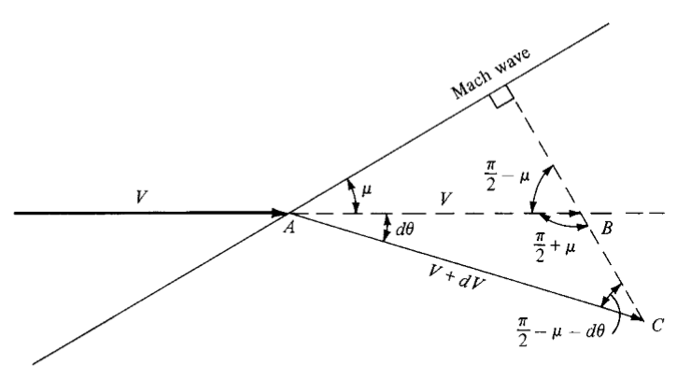

* Skipped some more stuff:
* A bit more:
* This equation relates the infinitesimal change in velocity dV to the infinitesimal deflection dθ across a wave of vanishing strength.
  + It is an approximate equation for a finite dθ but it becomes true as dθ -> 0
  + It is a differential equation that precisely describes the flow inside the expansion wave.
* If we integrate from region 1 (before the wave) to region 2 (after the expansion) we get this integral thingy, you have to do a bunch of crazy stuff but eventually you get this:
* You actually substitute that into the integral, which gives you the *Prandtl-Meyer function*:
* And carrying out the integration gives:
* There should be a constant of integration but apparently it drops out when you substitute this last equation into the definite integral form of the one before it.
  + It is chosen such that v(M) = 0 when M = 1
  + So, for a CPG:
* v(M) is given by the previous highlighted equation.
* Values for v as a function of M are tabulated in Appendix X.
* So basically, to answer the initial problem we had, you would do this:
  1. For a given M1, obtain v(M1) from Appendix C
  2. Calculate v(M2) from this last highlighted equation using known theta and step 1 results.

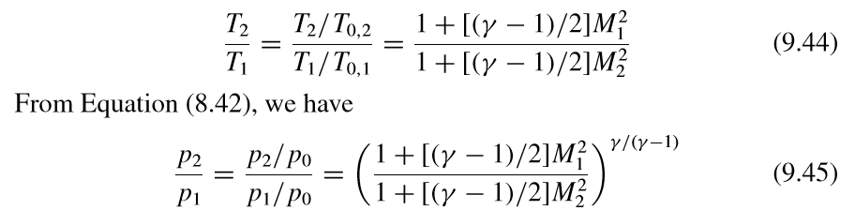

* 1. Obtain M2 from Appendix C corresponding to the value of v(M2) from step 2.
  2. P0 and T0 are constant throughout the expansion wave because it is isentropic so:
* To figure out your lambda and theta values, look at figure 9.26, it might help.
  + Theta is the total turning angle, lambdas are the angles of the waves, I’m not sure what angle the vs are.

9.7 – Shock-Expansion Theory: Applications to Supersonic Airfoils

* Consider a flat plate of length c at an angle of attack α in a supersonic flow.
* There is an expansion wave at the top as the flow is turned away from itself.
  + The pressure at the top, P2, is then less than the freestream pressure.

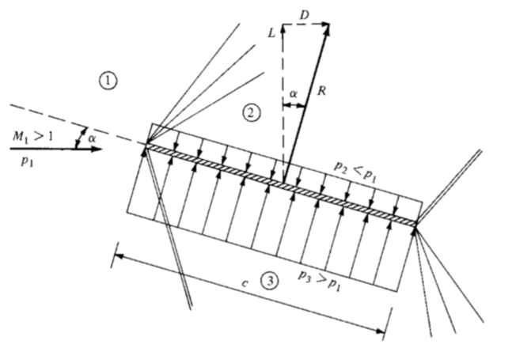

* + At the trailing edge, the flow must return approximately to the freestream direction.
  + A shockwave occurs at the trailing edge to turn the flow back into itself.
* On the bottom surface, there is an oblique shock, compressing the flow.
  + The pressure at the bottom, P3, is greater than the freestream pressure.
  + At the trailing edge, the flow must also return approximately to the freestream direction.
  + There is an expansion wave at the bottom of the trailing edge.
* Notice that the pressures at the top and bottom are uniform and P3>P1>P2
  + This creates a pressure imbalance and results in aerodynamic force R. For a plate of length c:

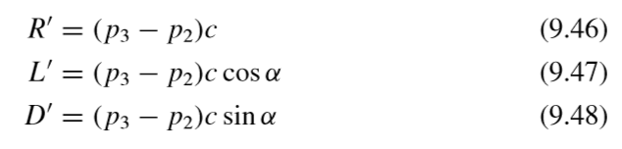

* You can calculate P3 from oblique shock properties and P2 from expansion shock properties.
* This is *exact* no approximations have been made.
* Note: For inviscid, supersonic flow.
* This flat plate problem is the simplest example of *shock-expansion theory*
* Use Shock-expansion theory for a small body made up of straight line segments and small deflection angles (small enough that no detached shock occurs)
  + The flow will go through oblique shocks and expansion waves
  + Pressure distribution on the surface can be obtained *exactly* from oblique shock and expansion theory.
* Consider a diamond shaped airfoil with 0o angle of attack

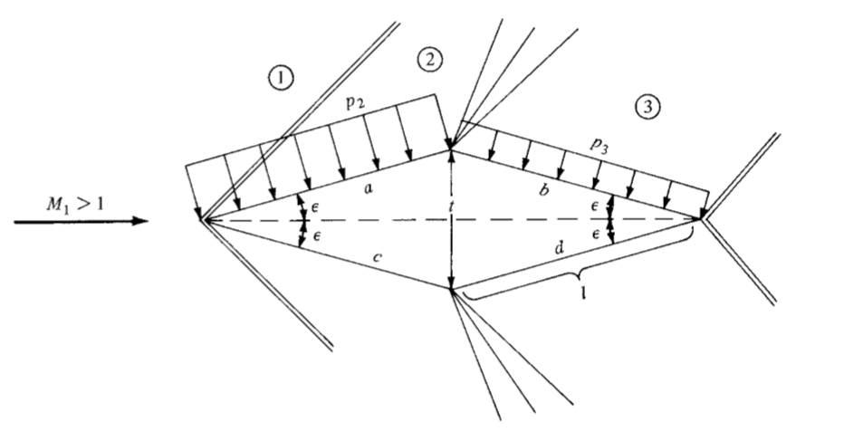

* The flow is first compressed through the angle ε (oblique shocks) on both sides of the leading edge.
* At the midchord, it is then expanded by 2ε (expansion wave)
* At the trailing edge, the flow is turned back to the freestream direction through oblique shocks
* Pressures on faces a&c are equal, pressures on faces b&d are equal.
  + P2>P3
* In the lift direction, the forces cancel out because they are even on the top and bottom
* However, the forces of drag on the front surfaces are greater than the ones on the back surfaces. So you get a finite drag:
* t is the airfoil thickness
* Note that this is specifically for a symmetric diamond shape airfoil at a 0o angle of attack.
* You obtain P2 from oblique shock theory and P3 from expansion-wave theory
* So apparently all the equations listed above are just special cases of what we found in Section 1.5. But, instead of using the integration, we just use the geometries of the bodies.
* Note also that the equations here predict a finite drag but, for 2D bodies in low-speed incompressible flow (Chapters 3 & 4) the drag was theoretically 0.
  + This is called *wave drag*, there is no d’Alembert’s paradox
  + It is caused by the increase in entropy and decrease in total pressure across the oblique shock waves.

9.8 – Comment on Lift and Drag Coefficients:

* All we needed to know (in the book examples) to calculate Lift and Drag (coefficients also) were:
  + The shape of the body
  + The angle of attack
  + The freestream Mach number
* This is consistent with stuff from chapter 1.5 or so where we found that lift and drag coefficients for a body are functions of only Reynolds Number, Mach number and angle of attack.
  + For inviscid flow, Re is not relevant, only M∞ and α
* **Remember that, if there is a consecutive expansion (or compression turn) you use the initial deflection turn angle to calculate lift/drag.**
  + **In the equations right before the last highlighted ones, notice that both use ε**

**Chapter 10: Compressible Flow through Nozzles, Diffusers, and Wind Tunnels**

10.2 – Governing Equations for Quasi-One-Dimensional Flow:

* The stuff we discussed in chapter 8 is for 1D flow, as if the streamtube had a constant area all across.
* If the area varies like in the picture below, then the molecules also have y and z components.
  + But if the area variation is moderate and the y and z components are small compared to the x, we can assume that the flow field varies only with x.
  + That’s why in the picture below, the thermos properties are written as functions of x only.
  + This is called quasi-one-dimensional flow

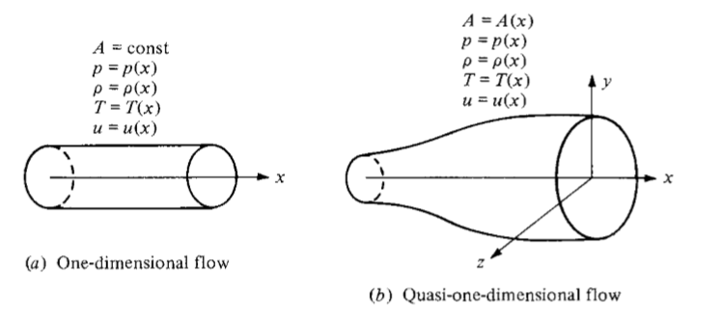

* The assumption we made here is an approximation but the derivations that we get by using the conservation equations are “physically consistent”.
* So then we proceed with those derivations using the integral forms of the continuity equation. We use the following control volume:

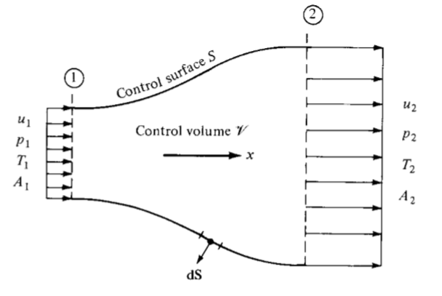

* For momentum (the derivation is actually somewhere in chapter 3):
* For the momentum equation (skipped the derivation):
* For the energy equation (skipped the derivation):
* What this last one is basically saying is that the total enthalpy is constant throughout the flow.
  + Which makes sense, it’s just another form of what we derived in 7.5
* Then, again, we add the equation of state and h = CpT to get our five equations and five unknowns.
  + But solving using these five equations takes a lot of algebraic manipulations
  + We instead do what’s described in 10.3
* So then what they do is obtain the differential form of the equations above.
  + For example, you know that since both sides of the first equation are equal, then they are equatl to a constant. So their derivative is 0.
* Then they also obtain the differential form of the momentum equation.
  + They apply the second equation to following control volume
  + I sort of skipped the rest of that derivation

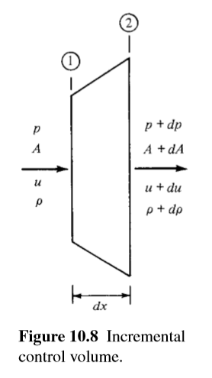

* This is the momentum equation for steady, inviscid, quasi-one-dimensional flow.
* **It is called *Euler’s equation***
* Finally, if you take the differential form of the energy equation, you get:
* So those three are the differential forms of the continuity equations for steady, inviscid, adiabatic, quasi-1D flow.
* Now we try to observe some properties using these equations
* If we actually do the derivation from the first:
* I skipped the rest of the derivation which gave this:
* Called the *area-velocity relation*
* It lets us observe all these cool things:
* For subsonic flow (0 ≤ M < 1):
  + The value in parentheses is negative (it becomes a negative coefficient)
  + This means that, if the area decreases, then velocity increase.
  + If area increases, velocity decreases

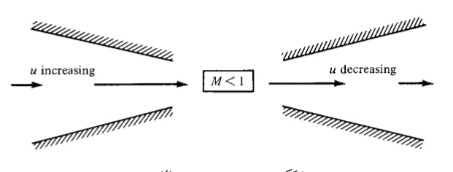

* For sonic flow (M = 1):
  + dA = 0
  + Mathematically, this means the equation is at a max or min (derivative = 0 means max or min)
  + Physically, it corresponds to a minimum area (the throat)
* For supersonic flow (M > 1):
  + The quantity in parenthese is positive (it become a positive coefficient)
  + Increase in area increases the velocity
  + Decrease in area decreases the velocity
  + So basically, if you want to accelerate the flow for supersonic speeds you actually need a divergent duct

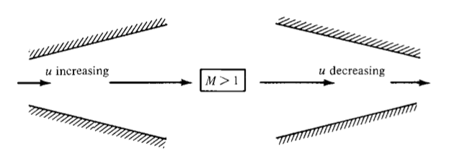

* With all this in mind, if we want to isentropically accelerate a gas from rest to supersonic speeds, we first accelerate it through a converging duct then, once it’s sonic, through a diverging duct
  + Converging-diverging nozzles.
* You can do the reverse as well:
  + Use a CD nozzle to slow down supersonic to subsonic speeds. Slow it down to sonic speeds in convergent duct, then slow that sonic flow down with diverging duct.
* The smallest area of the converging diverging duct is called the *throat*
* In both cases, the speed at the throat is M = 1

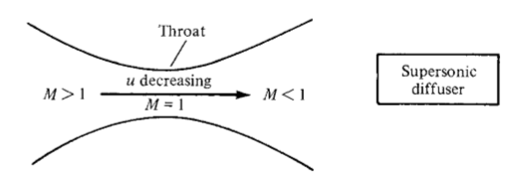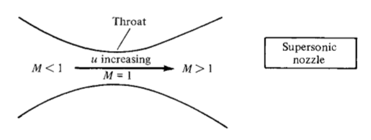

* The last note about the last highlighted equations is that, if M = 0, then the equation integrates to Au = constant.

10.3 – Nozzle Flows:

* Consider the following duct:

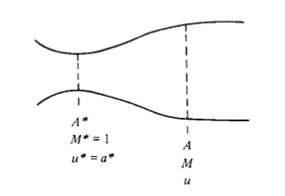

* From the first conservation equation
* You can use this equation along with isentropic properties and one of the definitions of Mach number to get:
* Remember that M is the Mach number on the second side of the nozzle in the diagram above
* This is called the *area-Mach number relation*
  + **It tells you that the Mach number is a function of the ratio of local area to throat area**
  + Remember that A ≥ A* so the ratio is always greater than or equal to 1
* NOTE THAT THIS EQUATION YIELDS TWO RESULTS, ONE SUBSONIC AND ONE SUPERSONIC
  + The actual value depends on the inlet and outlet pressures
* For subsonic values of M:
  + As A/A* decreases, M increases
* At M = 1, A/A* = 1
* For supersonic values of M:
  + As A/A* increases, M increases

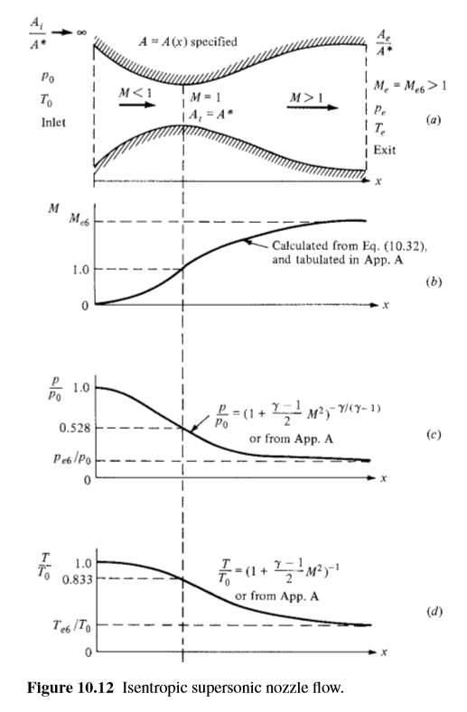

* Imagine a convergent divergent nozzle, with a very large Ai/A* with a large, stationary, gas reservoir
  + The subsonic Mach number at the entrance must be very small (near 0)
  + So P and T at inlet are essentially P0 and T0
* Note that the table in appendix A starts with the converging section of a nozzle and then the diverging section. You get all your values from there.
* Skipped short part of an explanation
* **Keep in mind that the following is if incoming flow is subsonic only (I think)**
* The flow properties in the nozzle are a function of the local area ratio and are obtained like this:
  + You get the local Mach number from the last highlighted equation or from the tables
  + **Basically, given your area ratios for the inlet and outlets to the throat, you can find the local Mach number using the equation or the table in the converging and diverging regions.** (Make sure to use the correct region)
    - It will basically have the shape of the top graph
  + Once you have the Mach number, you can use the isentropic relationships equations or the table to find the temperature, pressure and/or density ratios.
    - They will have the shape in the other two graphs of the last figure
* Remember that the Mach number distribution and consequent distributions of P and T depend only on the Area ratio
* Flow won’t happen if you just put a nozzle on your table; for inviscid flow, the only mechanism to make the gas accelerate is a pressure gradient.
  + The exit pressure must be less than the inlet pressure.
  + More than that, if you want to create supersonic flow, the pressure ratio must be exactly what is given in Appendix A for a known exit Mach number
  + If it is different, your graphs won’t be the same as in the last figure
* **This next part answers your question about what happens if you have different inflow speeds (like below Mach 1)**
* So now we look at what happens when the pressure ratio isn’t what is specified in Appendix A
  + If the pressures are equal, there is no flow.
  + If Pe drops a tiny bit (say 0.999P0), the pressure difference will create a very low-speed sub-sonic flow in the nozzle (gentle wind). The speed will peak at the throat AT A Ma MUCH SMALLER THAN 1 (like in curve 1 on the first graph below) and then slow down in the diverging section. Note that A at throat is not A* in this case.
    - A* becomes a reference value, it is the area the flow would have if it was somehow accelerated to sonic speeds, but if this happened, the flow area would have to be decreased.
    - Basically, for a purely subsonic flow At > A*
  + If you reduce Pe further but not enough, you get curve 2
  + **If you reduce Pe further, you can get sonic flow at the throat, but the downstream flow will still be subsonic**
  + For a given nozzle shape, there is only one pressure ratio that will give the curves in the above graphs. But there are an infinite amount that will produce the curves below (3 of them are sketched)
    - Each correspond to P0 ≥ Pe ≥ Pe, 3

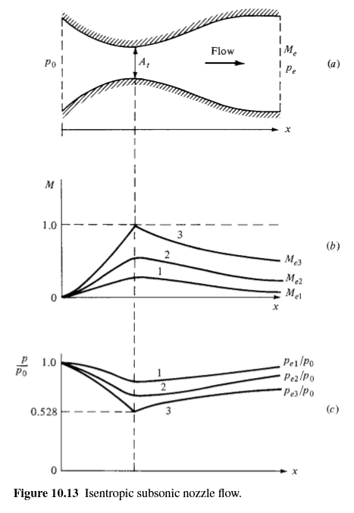

* But what if we decrease Pe even further?
  + Originally, as we decrease exit pressure, flow at the throat accelerates. So mass flow rate does too.
  + We calculate mass flow rate at the throat
  + As Pe decreases, increases and decrease. But increases a lot faster than throat density decreases. So mass flow rate increases
  + This continues until Pe = Pe,3 (the highest exit pressure to cause sonic flow at throat), at which point:
  + But if you decrease exit pressure more than that, the mass flow rate doesn’t change!
  + Also Mach number at throat remains 1! Always!
  + **Basically, once the flow at the throat becomes sonic, everything before the throat becomes fixed. Disturbances can’t travel upstream.**
    - So the flow in the converging section can’t even tell that the exit pressure is still decreasing!
  + This is called *choked flow*

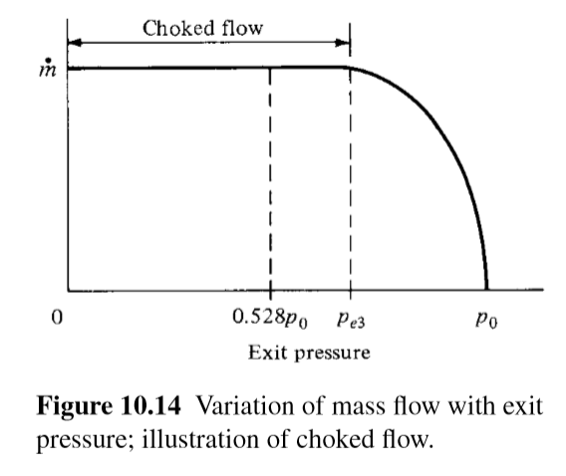

* But anyway, in terms of the graphs in figure 10.13, what actually happens if we keep decreasing Pe?
  + Nothing changes for the converging section, you get the exact same curve for the left side of curve 3.
  + But for the diverging section, supersonic flow starts to appear.
  + At this point, Pe is still too high for the entire flow in the diverging region to be insentropic & supersonic.
  + Instead, you get a shock wave downstream of the throat.
  + In front of that shock wave, the flow is supersonic and isentropic. Behind the shockwave, flow is subsonic.

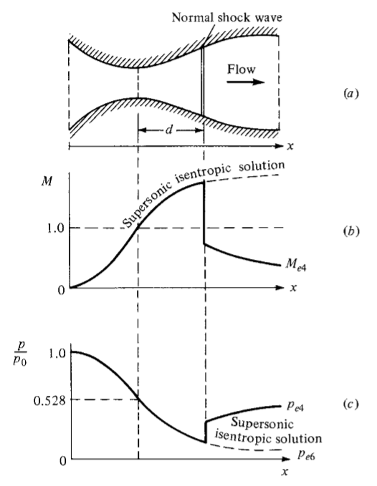

* + The subsonic flow behind the wave then slows down because it’s in a divergent duct.
    - There is a pressure increase
  + Before and after shock, flow is isentropic but entropy **increases across the shock wave.**
  + The location of the shock wave is such that the increase in static pressure across it and its subsequent increase be just right to reach Pe, 4 at the exit.
  + As Pe decreases further, the shockwave moves towards the exit.
* Now we look at the flow downstream of the nozzle exit:
  + *Back pressure* is the pressure outside of the nozzle
* When flow at the nozzle exit is subsonic, back pressure equals exit pressure.

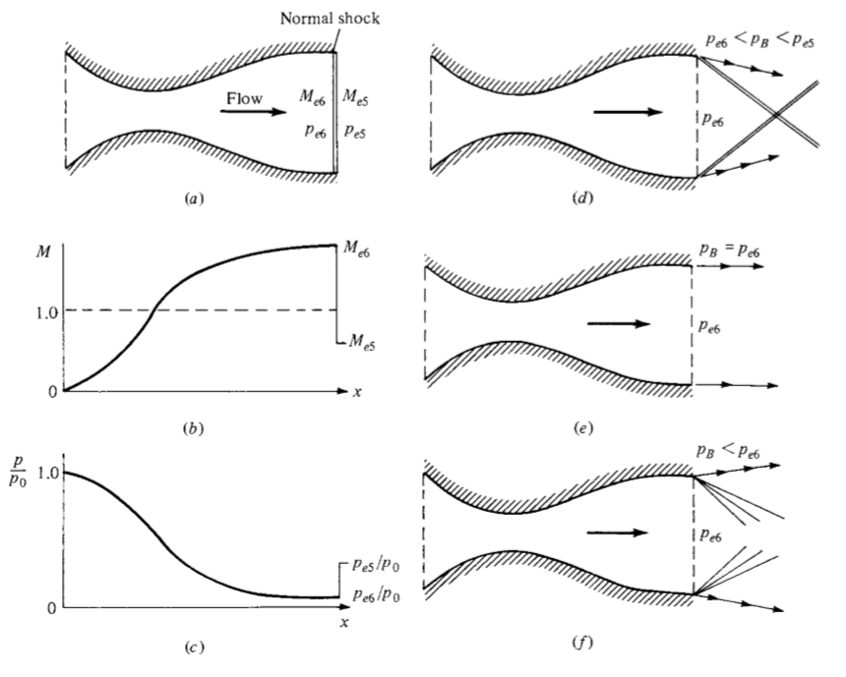

* I skipped the rest of this explanation, it relates to back pressure in relation to exit pressure.
* For mass flow rate:
* The terms with a 0 subscript are the reservoir values
* THIS IS FOR CHOCKED FLOW, IF THE FLOW IS NOT CHOCKED, MASS FLOW ALSO DEPENDS ON EXIT PRESSURE
* **If one or more of the three terms in that equation change, then the horizontal part of the mass flow rate graph raises or lowers accordingly**

10.5 – Supersonic Wind Tunnels:

* Say that you want to create a speed of Mach 2.5 to test a model of a supersonic vehicle.
* You might think of using a CD nozzle and exhausting it as such:

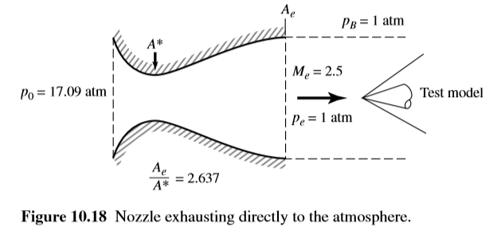

* To make sure that the free jet (outgoing air) does not cause expansion waves or shock waves, the nozzle exit pressure must be the same as the back pressure (1atm)
* But getting a 17.09atm pressure reservoir is expensive af
* So, instead, you use something like Figure 10.19

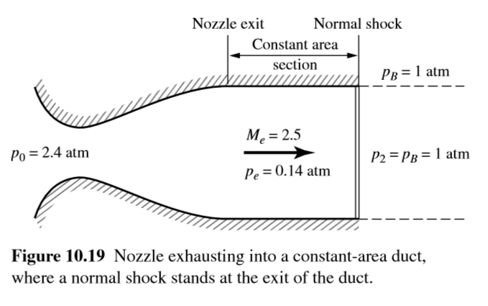

* You (somehow) know that the pressure after the normal shock must equal the background pressure
* At M = 2.5, you can calculate the pressure upstream of the shock.

I skipped the rest but, basically, you add a second throat because the normal shock causes a huge drop in stagnation pressure and, for the two throats you get the following (where P0, 2 is smaller than P0, 1 and the second throat is always larger than the first, unless it’s an ideal isentropic diffuser in which case they’re equal).

**Our Own Notes: Fanno Flow**

Under and Over Expansion:

* Under-expansion: the exit pressure is greater than the back pressure so it spreads out:

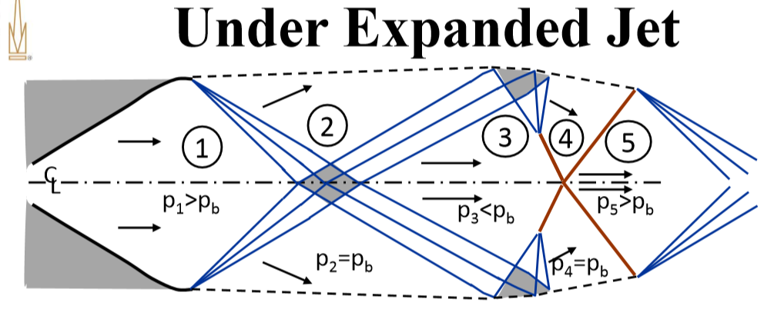

* Over-expansion: The exit pressure is lower than the back pressure so it goes in:

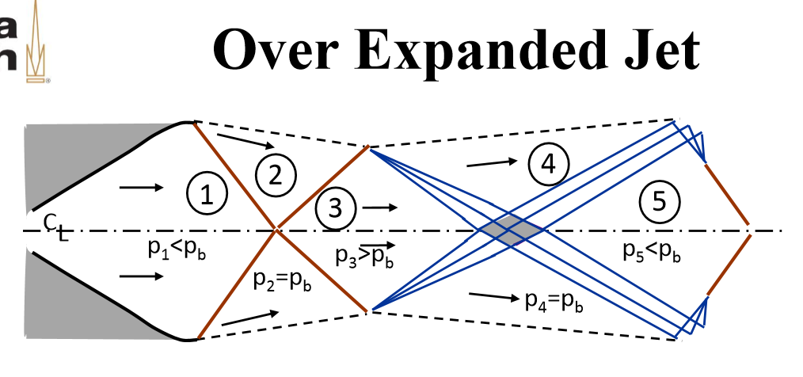

Friction and Heat Transfer:

* What if the flow is not isentropic?
* Non-reacting TPG/CPG, no body forces, viscous work negligible

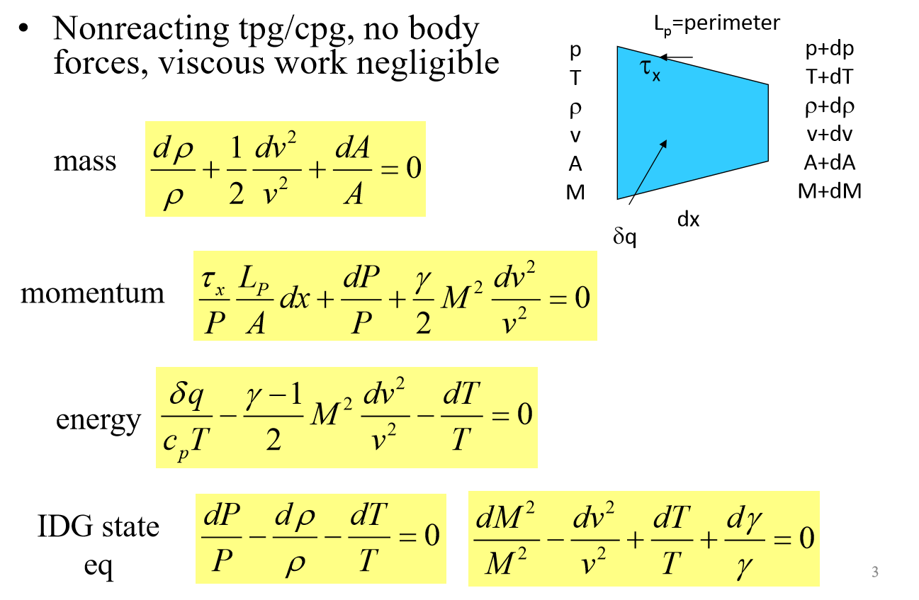

* We write the friction induced shear stress in terms of a friction factor:
  + Darcy Friction Factor:
  + Hydraulic Diameter:
  + I think Lp here is just the circumference or area. For a circle, D = diameter. For a square, D = side length
* I think if you substitute those into the momentum equation, you get:

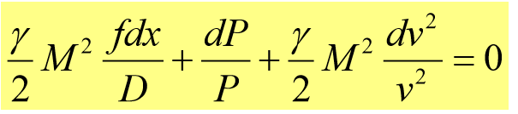

* If you put those into the conservation equation you can show:

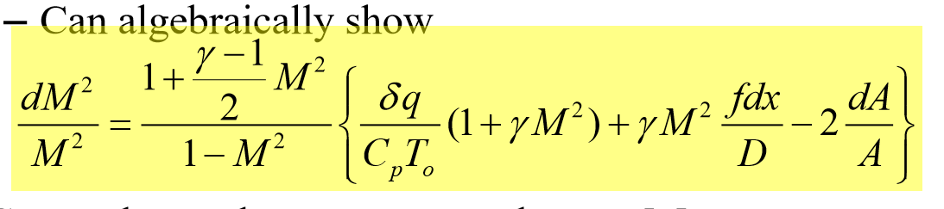

* If you stare at this long enough, you’ll notice that it shows that M can vary because of three things:
  + Heat transfer (first term in curly braces):
    - Heating has same effect as decreasing area (accel subsonic, deccel supersonic)
    - Cooling has same effect as increasing area (deccel subsonic, accel supersonic)
  + Friction:
    - Increasing friction has same effect as decreasing area (accell subsonic, deccel supersonic)
  + Area change: Which we’ve already studied in nozzles
* In terms of Sonic flow:
  + Friction drives the flow towards M = 1 and increases entropy
  + Heating drives the flow towards M = 1 and increases entropy
  + Cooling drives the flow away from M = 1 and decreases entropy
* I’m not sure but it says something like: as you go from subsonic to super sonic
  + For isentropic flow, dA = 0: You get the sonic point when dA = 0 (at the nozzle)
  + For friction or heating, dA>0: You get the sonic point in the diverging section
  + For cooling, dA<0: You get the sonic point in the converging section
* Using the conservation equations, you can get an equation for each thermodynamic property as a function of dM2
  + You can get a general solution for these by numerical integration (hard stuff)
* You can get analytic solutions one at a time
  + Isentropic flow: Already solved, only dA changes
  + Fanno flow: only friction changes
  + Rayleigh flow: only heat transfer changes

Fanno flow:

* **Steady, 1D, constant Area, adiabatic flow with no external work but friction**
* Since it is adiabatic and no work is done ho = constant

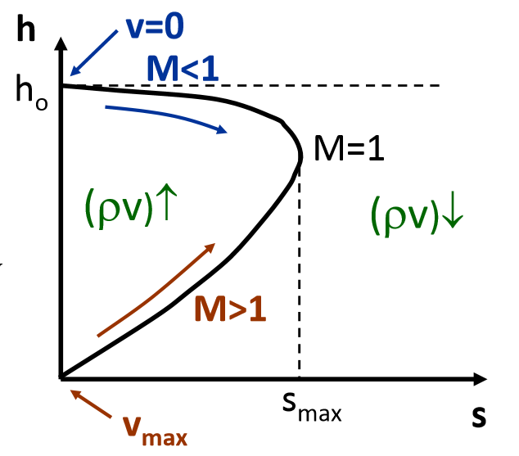

* Since A = constant, mass flux = ρv = constant = G
  + ho = h + G2/2ρ2
* On an h-s diagram, you can draw the Fanno Line
* The changes in velocity (due to friction) cause an entropy change
* Friction can only increase entropy
  + Also, it can only make the flow approach M = 1
  + **Friction alone is not enough to make the flow go from sub-sonic to super sonic**
* If you’re given ρv, ho and/or s, there are two solutions, sub sonic and super sonic
  + **If mass flux changes, you get a new Fanno line**

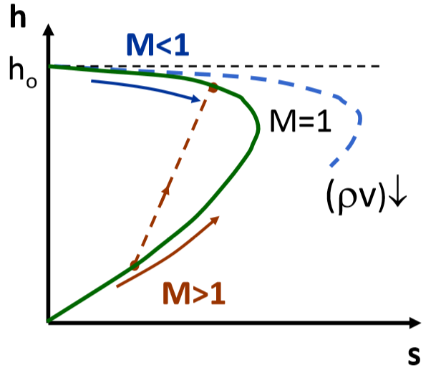

* The total friction experienced by the flow increases with the length of the tube.
  + If the duct/tube is long enough (Lmax), you get M = 1 at the exit
  + If L>Lmax the flow is already chocked so:
    - For subsonic flow, you get a new Fanno line (more to the right)
    - For supersonic flow, you get a shock
* If we go back to that crazy equation and set dq = dA = 0, you can solve for each property and write them as a function of only Mach number:

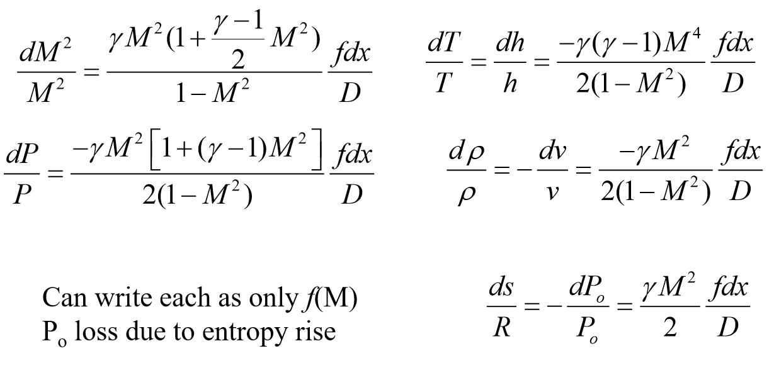

* If you look at the signs on these equations, you can sees how the properties are changed by friction as the flow changes. The difference is because of the 1 – M2 term.
  + Note that ho and To are constants

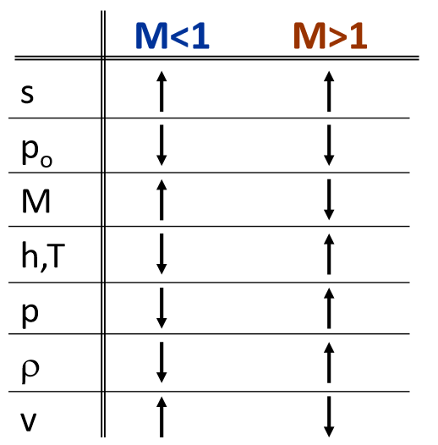

Skipped some stuff (an example and 3 math slides)

* If the length of the duct is below the maximum length:
  + As the back pressure decreases, you get a shock, the more it decreases, the more this shock moves inwards. Until it reaches the throat
* If the length of the duct is greater than the maximum length:
  + The flow can’t become subsonic with just Fanno flow, you need a shock in the duct
  + As the back pressure decreases, the shock moves downstream (outwards)

Didn’t add a few useful diagrams here

Rayleigh flow:

* **Steady, 1D, constant area, inviscid flow with no external work but with reversible heat transfer**

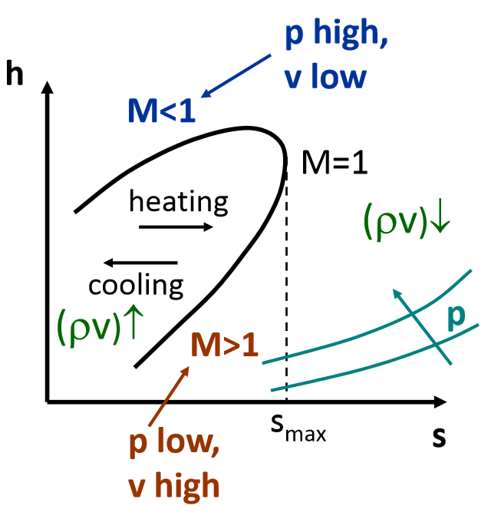

* Conservation equations:
  + Since A = constant, mass flux = ρv = constang = G
  + Since no forces but pressure: P + G2/ρ = constant
* We can draw the Rayleigh line on an h-s diagram
* ds = dQ/T (it is reversible)
  + Heating increases s, cooling decreases s
  + M = 1 at maximum
* Changing the mass flux creates a new Rayleigh line
* Heat addition can only increase the entropy
* If you add enough heat exit flow can reach M = 1 (maximum Q)
* If Qin > Qmax
  + Subsonix flow moves to a different Rayleigh line
  + Supersonic flow experiences a shock

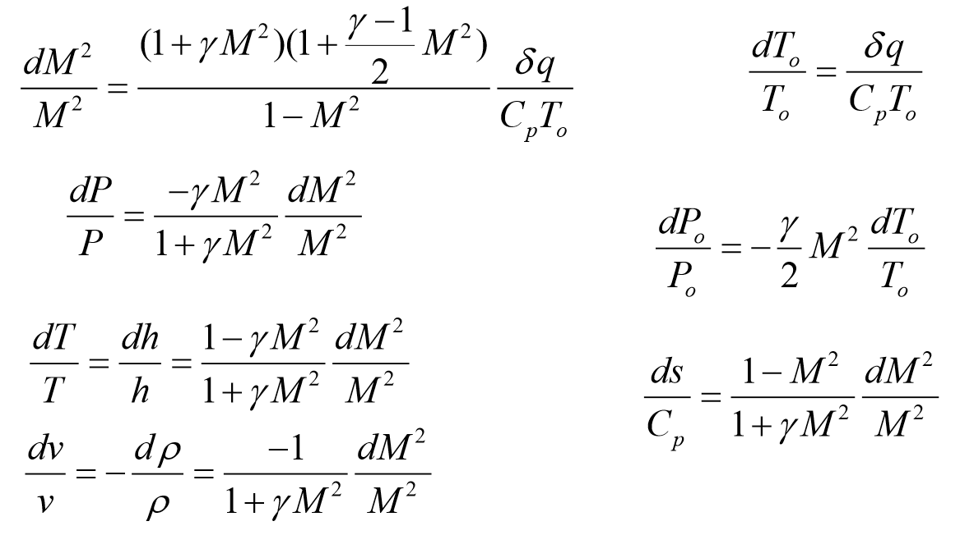

* If you go back to that original crazy equation and assume f = dA = 0, then solve for each TD property:
* And, again, if you look at the effect of all of these:

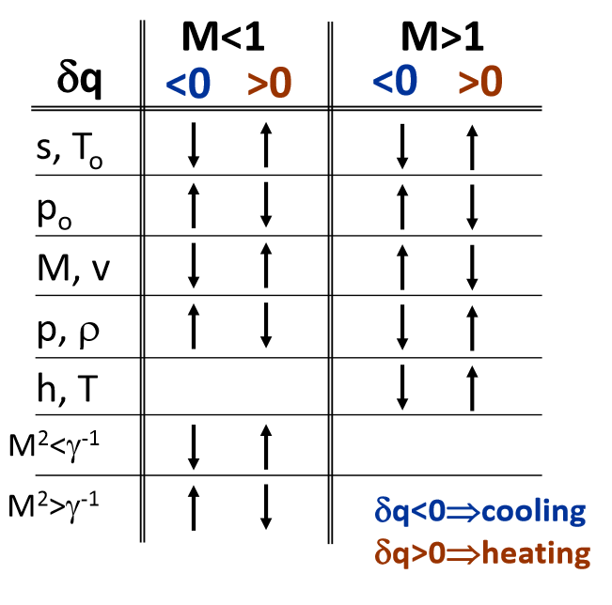

* On the graph above, you get the top peak (dh/ds = 0) as M =1/sqrt(y)
* You get the side peak (dh/ds = infinity) as M = 1